What do you see when you go down to the coast?

*Keep a regular note of what you see*

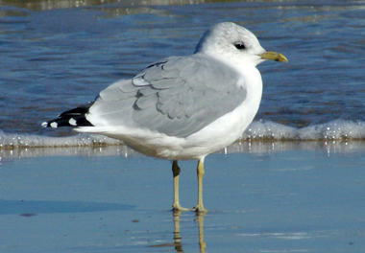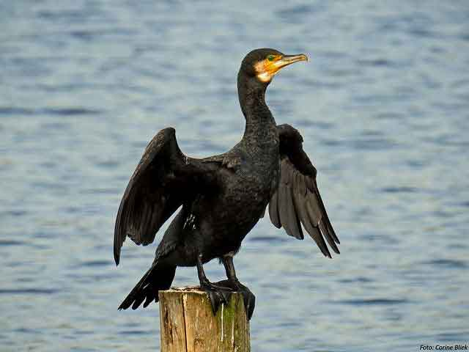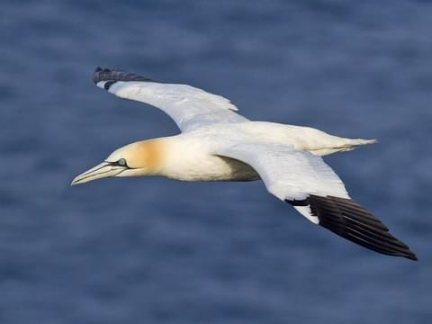

Northern

Gannet

Common gull

Cormorant

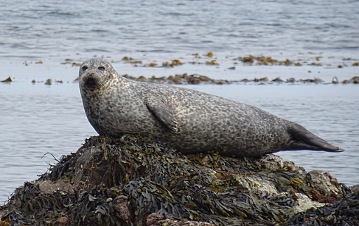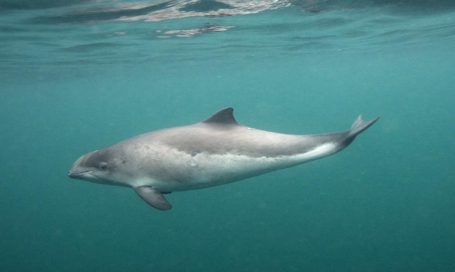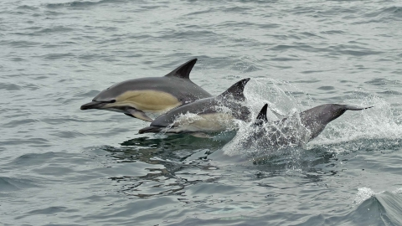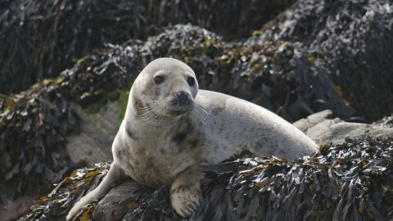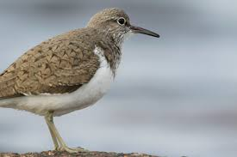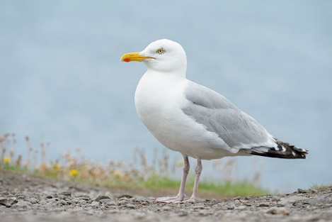

Log what you see on your coastal walks. Include insects, litter, flowers, seaweeds, amounts of driftwood (write on the back)

Add in your location:

Date & time & weather:

Dolphin

Common

seal

Porpoise

Sandpiper

Grey seal

Herring gull