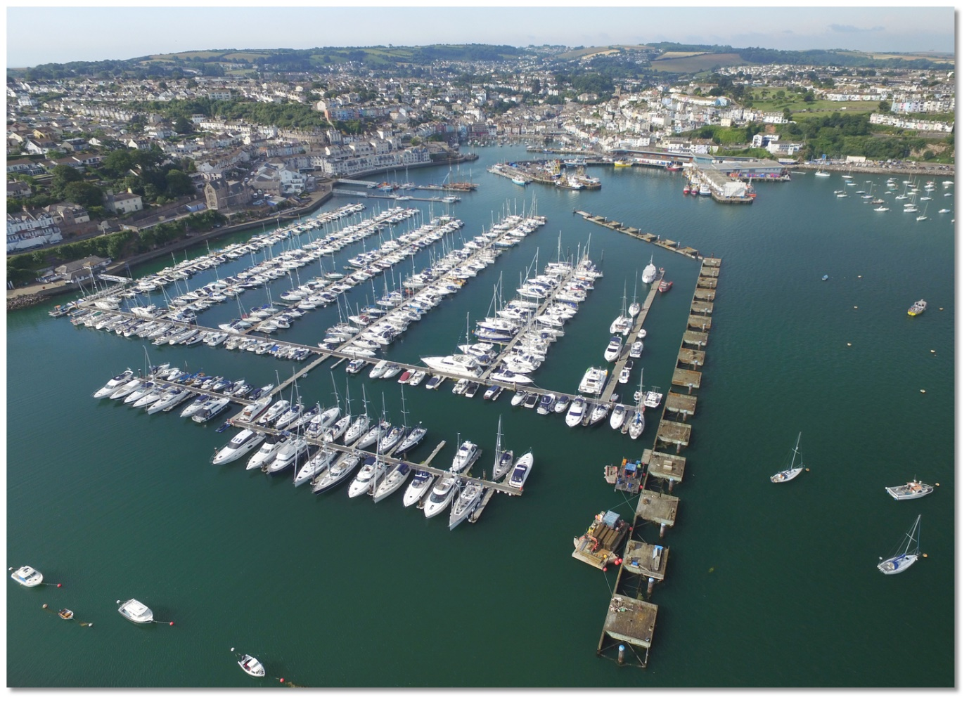

1. Pick a location that has a mixture of users.
2. What creatures do you think you might find there?
3. What humans do you expect to see?
4. Is there any pollution or litter? Where is it an how much?
5. Are there sudden rises in impact on tourist days or specific times of the week?
6. How do you want to record this (on a table/form, marking a map with different coloured pens, making a daily video etc.)
7. Do you need to borrow equipment (binoculars, clipboard, high vis jacket) let us know if we can help!
8. How long will you record this?

**Send your records to sealprojectuk@gmail.com**

**Can you carry out an environmental impact survey?**